**Name :-Manan Sharma**

**Roll no :- 3**

Step 1 – Hyper V comes pre-installed on windows 10. First we need to enable hyper-v services from control panel

Step 2 – open start menu after successfully enabling hyper-v and type “Hyper-v”

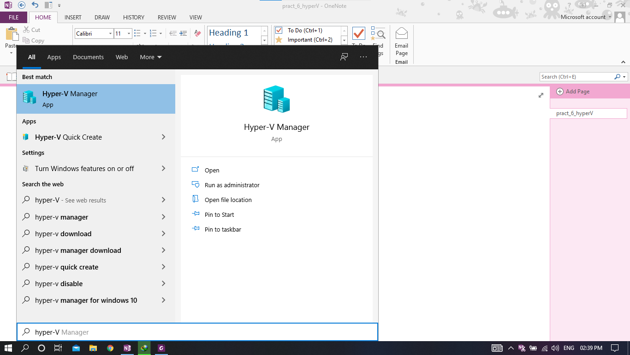

Step 3 – Select Hyper – V manager. After opening Hyper-v we need to create virtual switch.

Step 4 – Select Virtual Switch Manager from Actions tab in Right side window

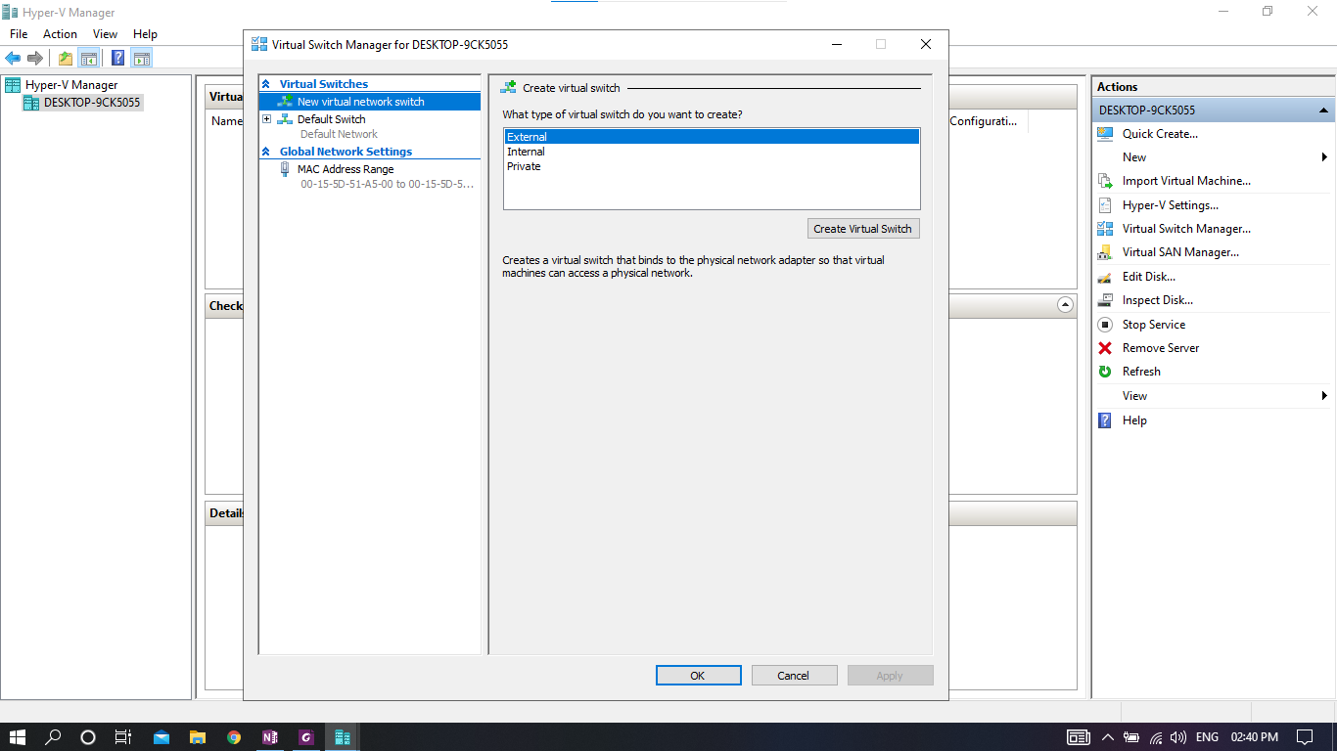

Step 5 – Select “External” and click on Create Virtual Switch button

Step 6 – give name to virtual switch and click apply and OK

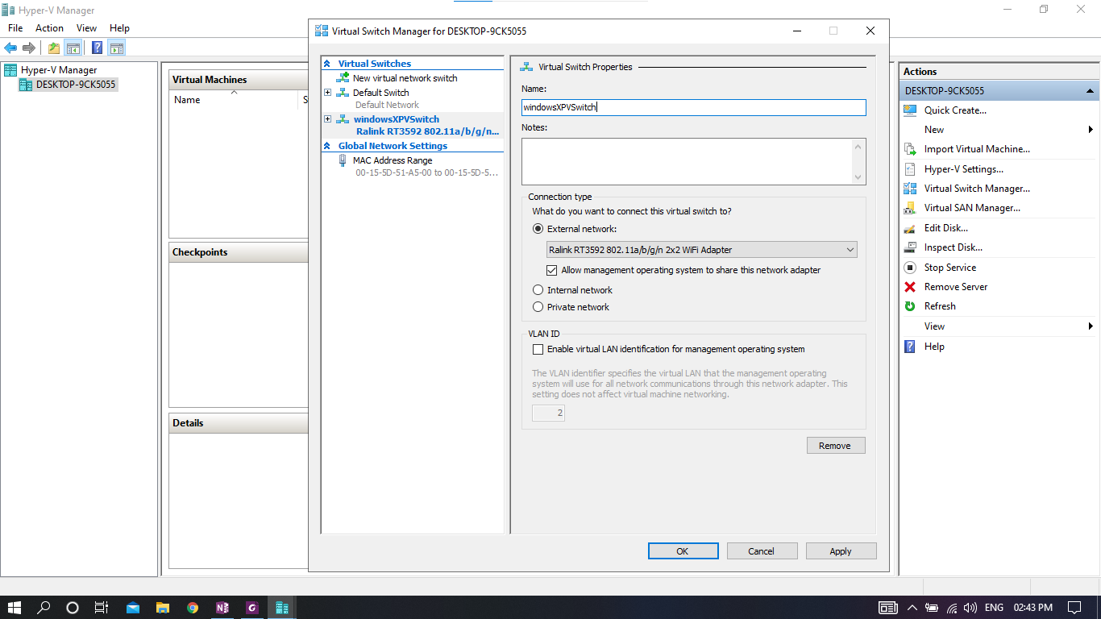

Step 7 – right click on machine > new > select virtual machine…

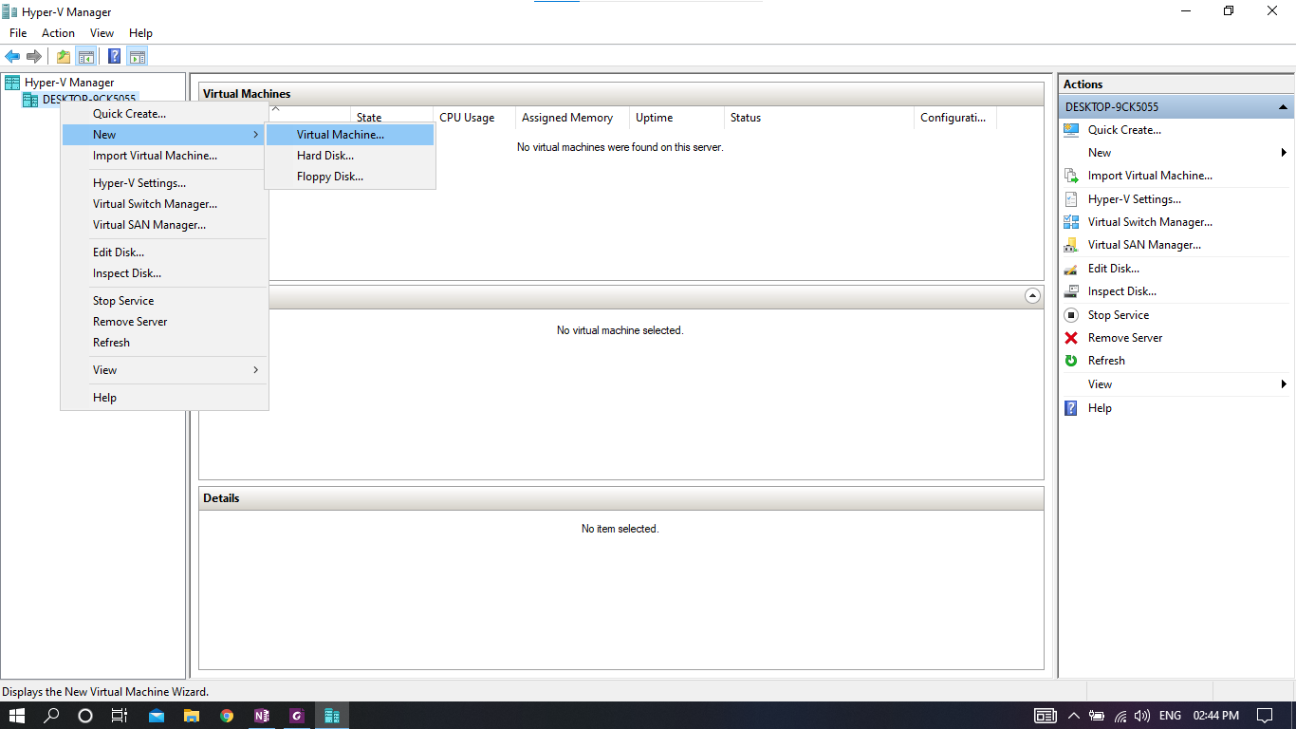

Step 8 – Click next

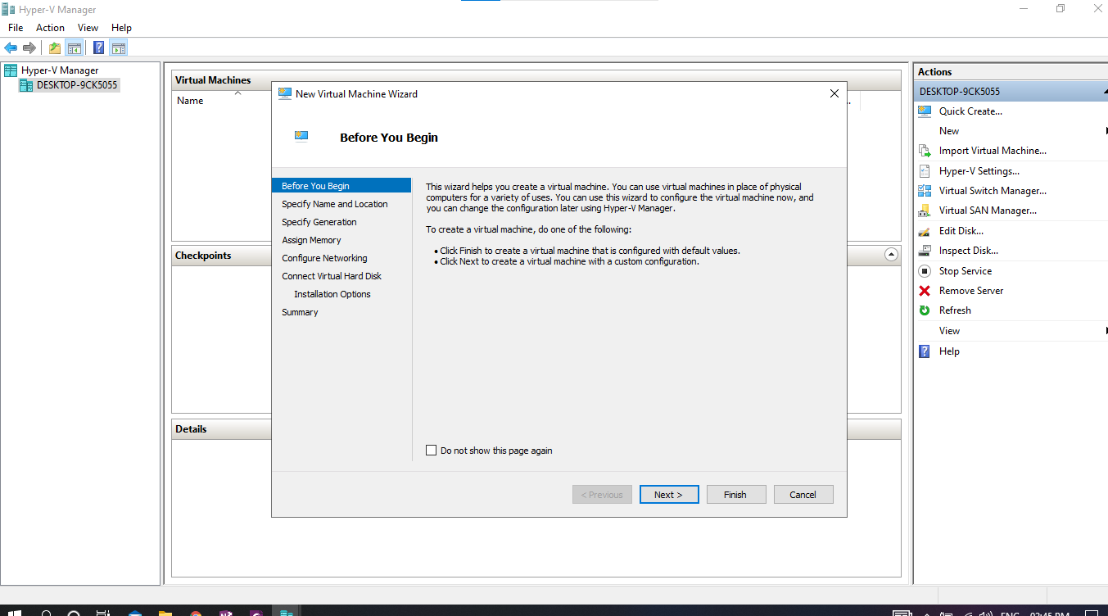

Step 9 – Name virtual machine and give location address or keep default location.

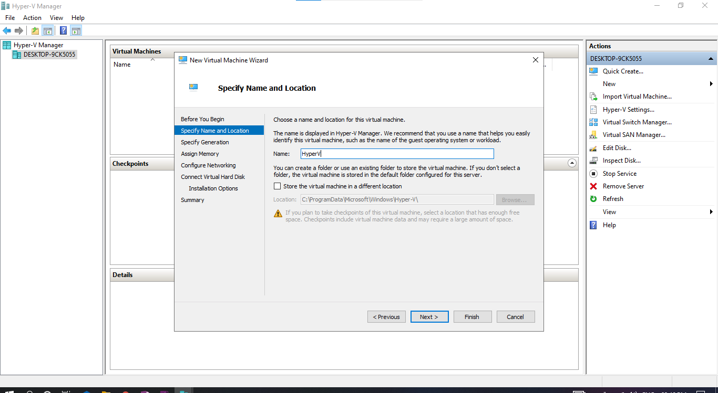

Step 10 – choose generation 1

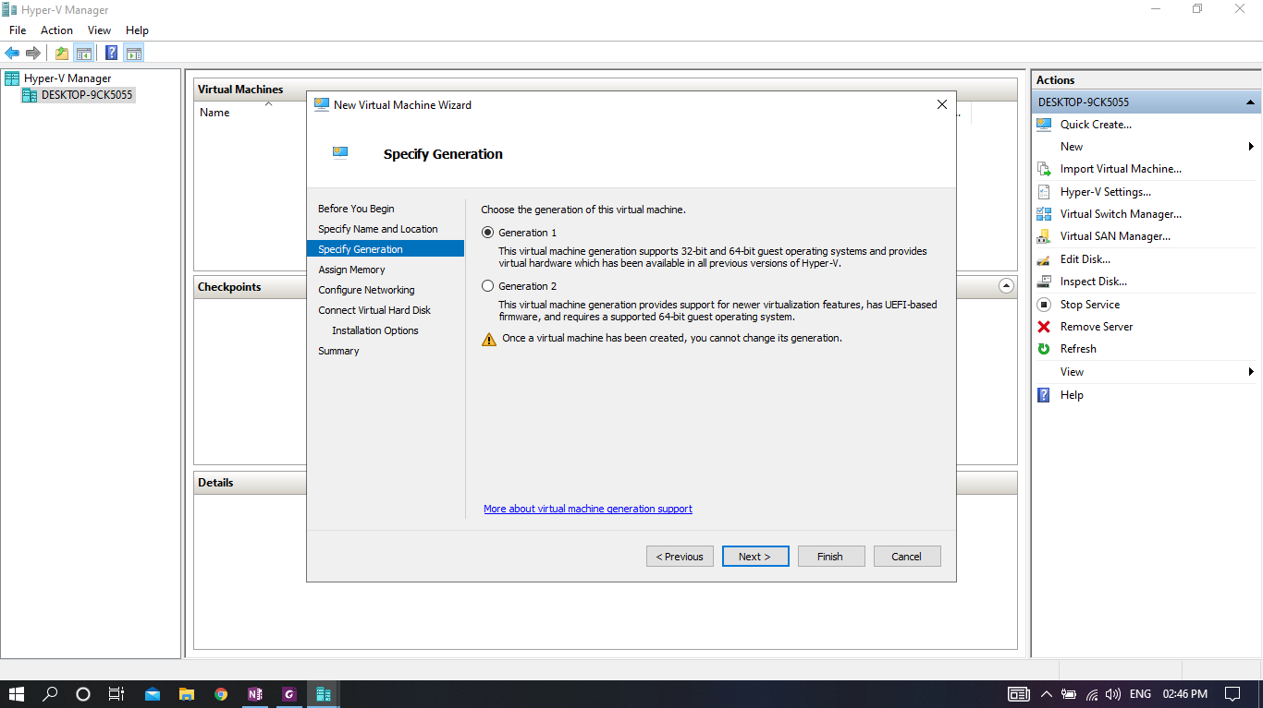

Step 11 – assign memory between 512 mb to 2 gb is enough for windows xp

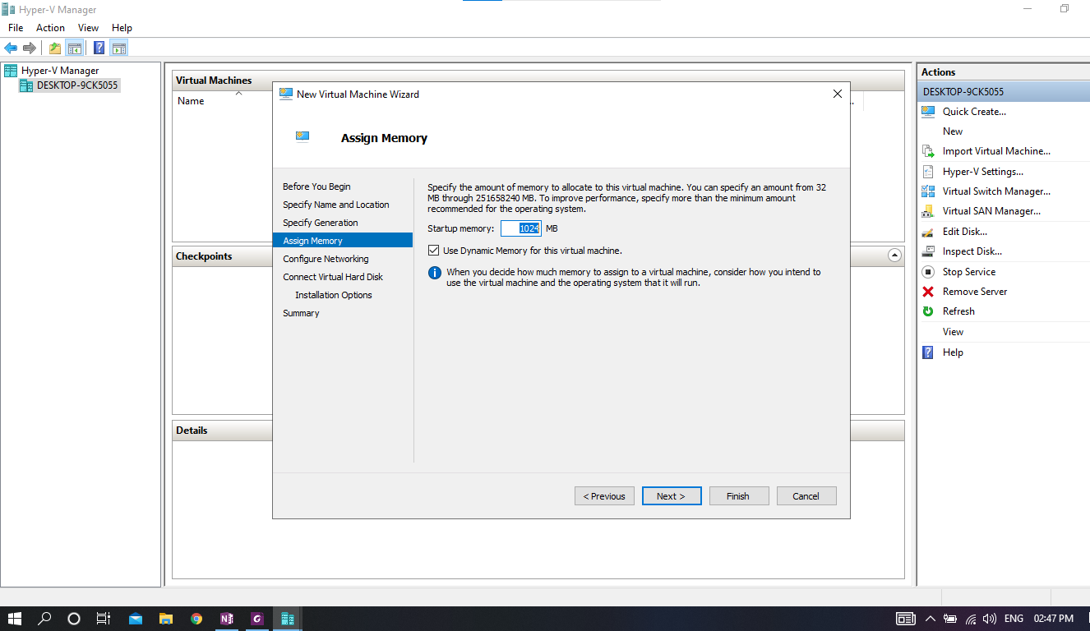

Step 12 – choose virtual switch created in above steps

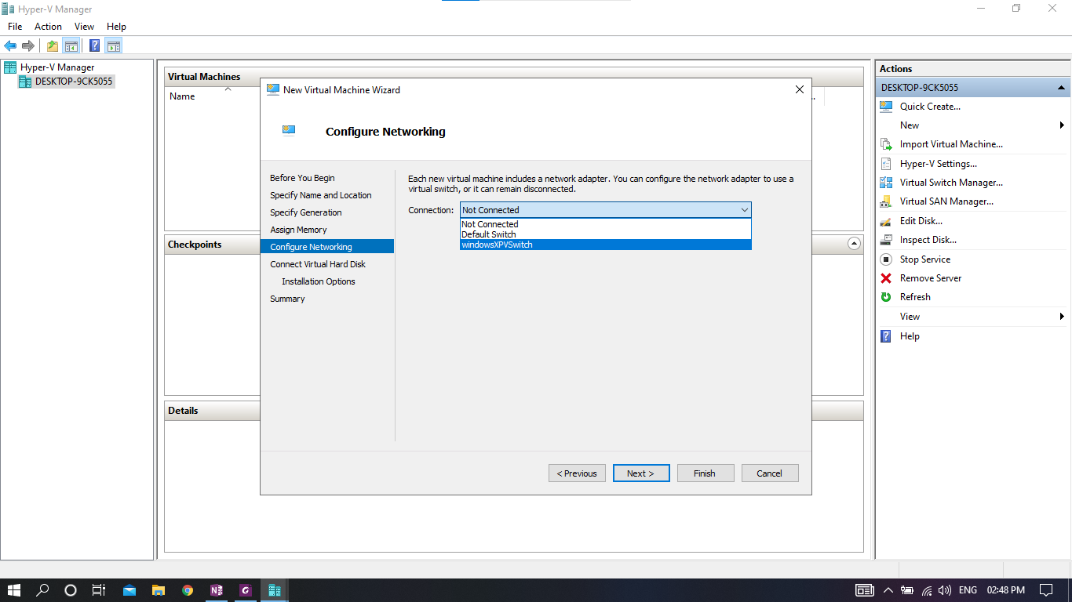

Step 13 – assign virtual hard drive memory for virtual machine and location

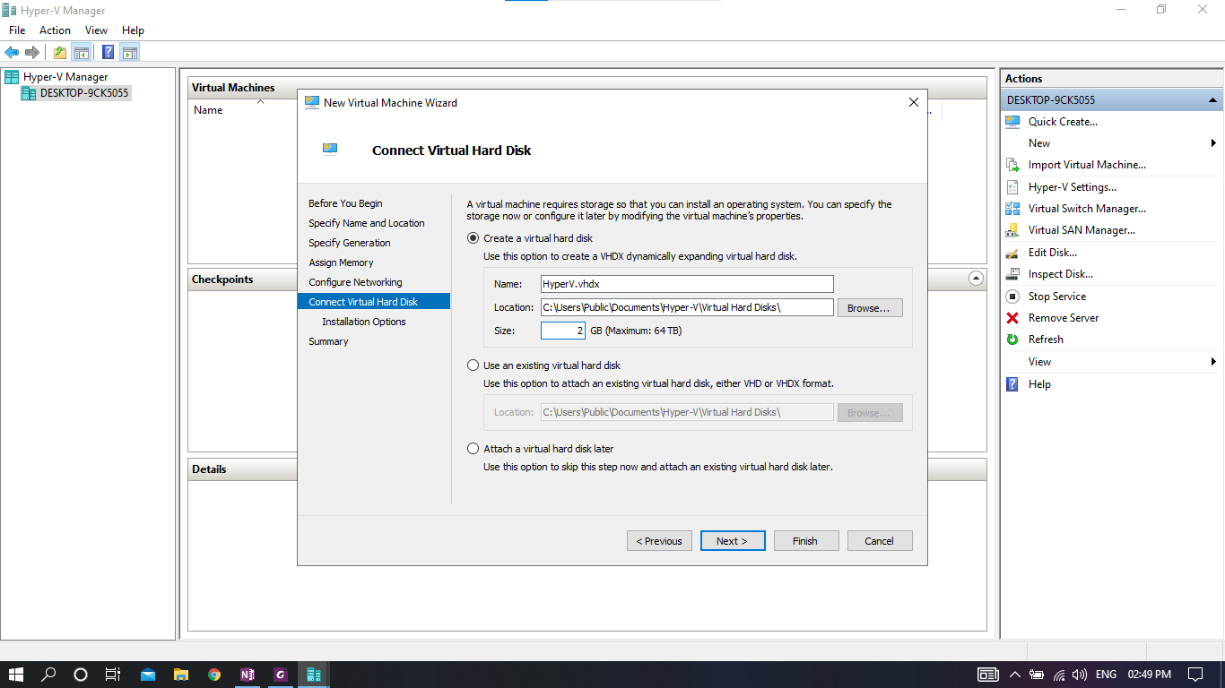

Step 14 – choose windows xp iso file and click next

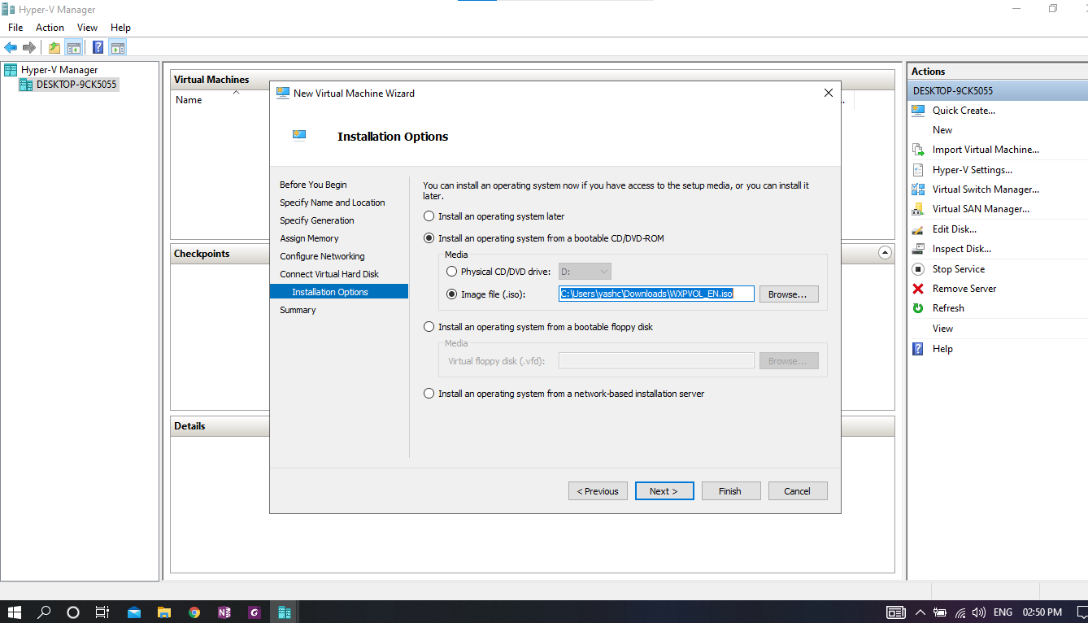

Step 15 – click finish

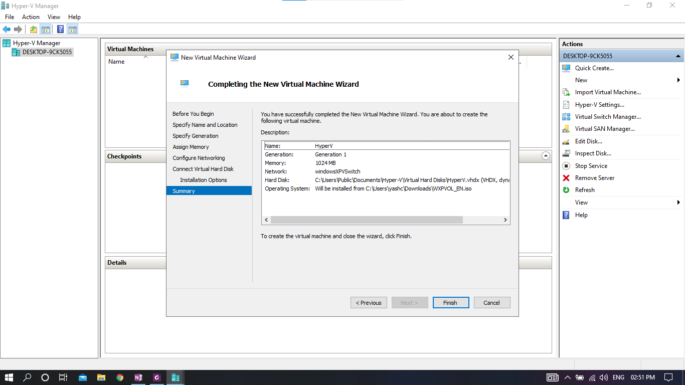

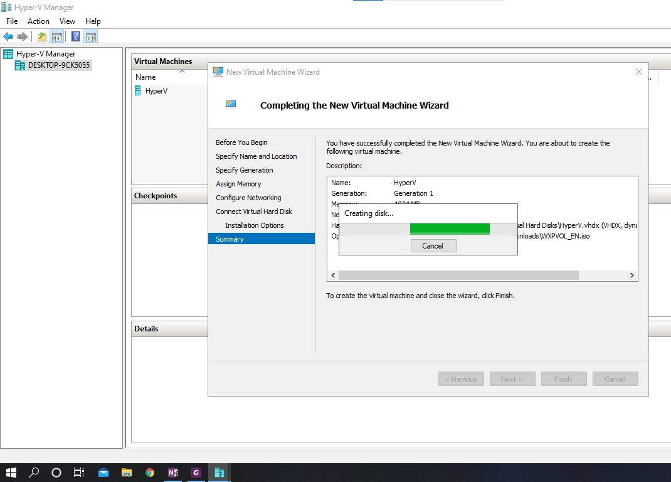

Step 16 – virtual machine is established

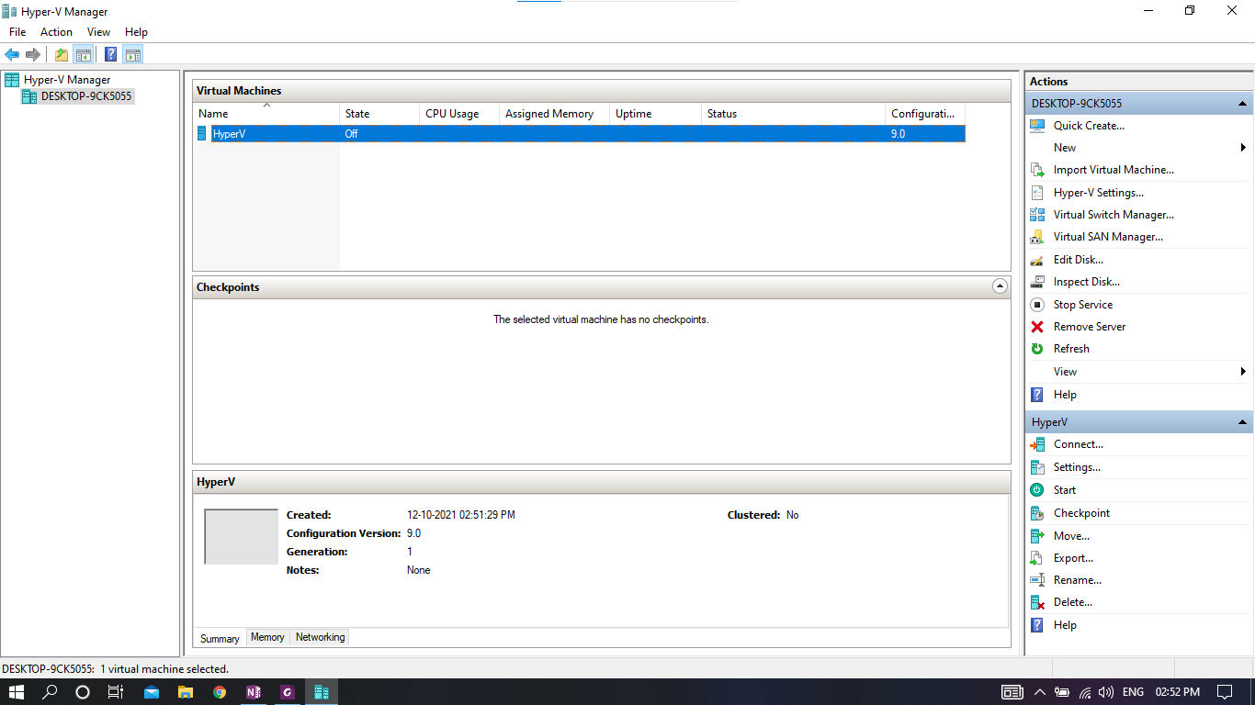

Step 17 – right click on created virtual machine choose connect

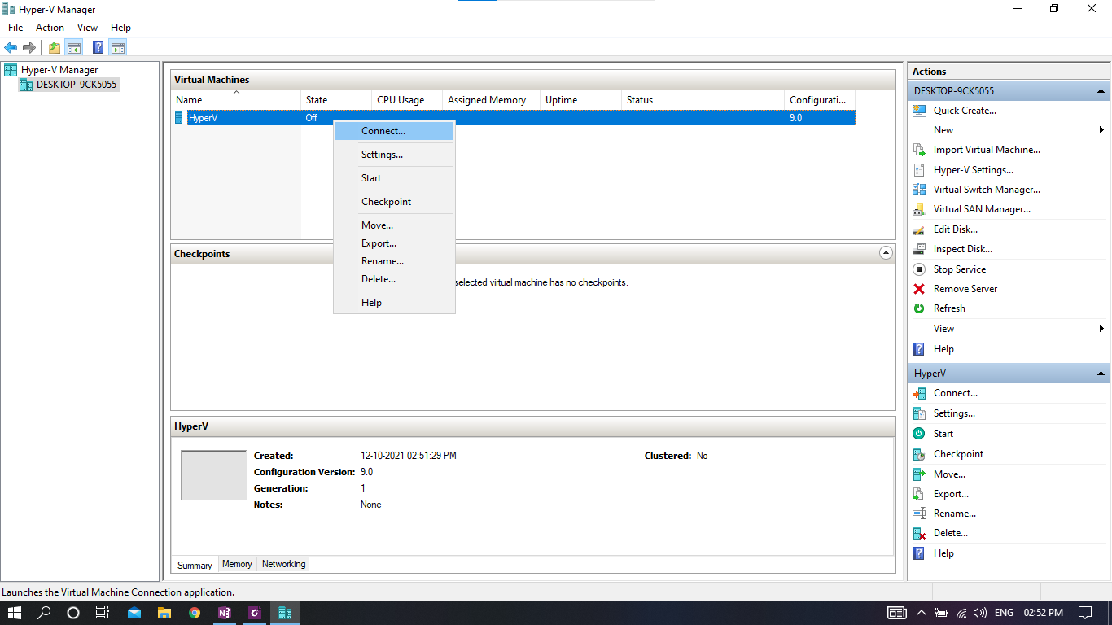

Step 18 – virtual machine windows will open and choose start to start VM

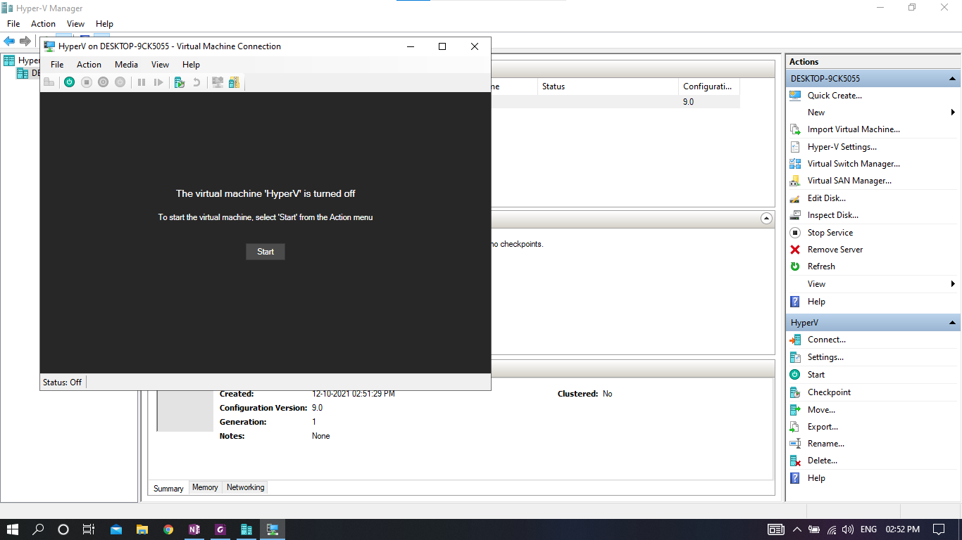

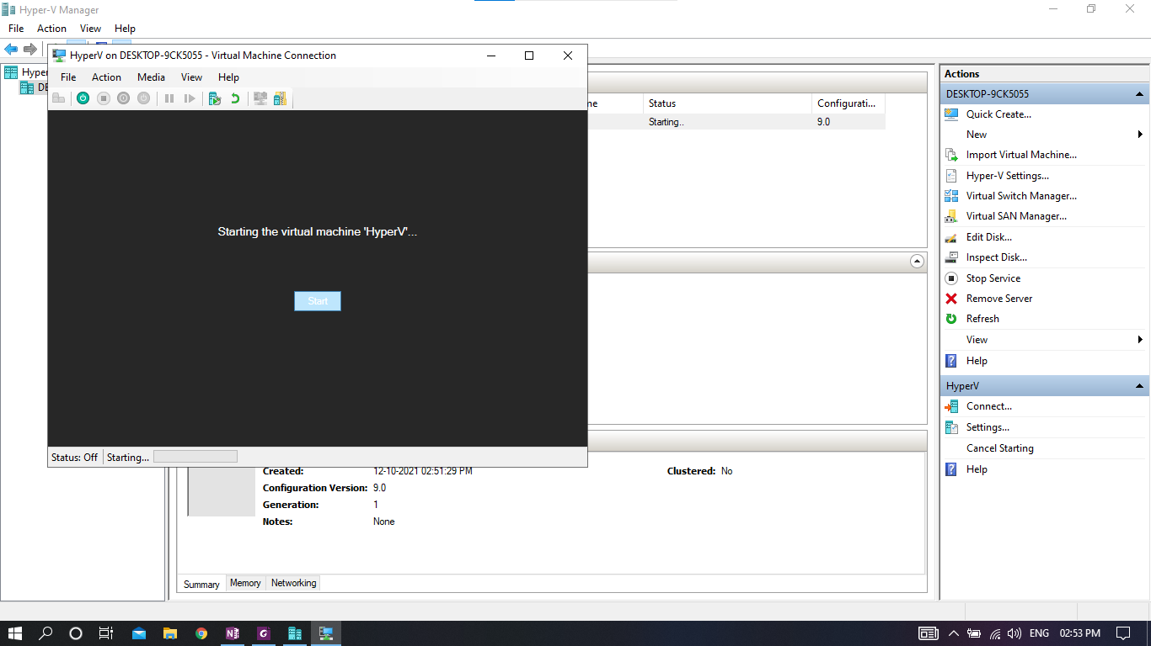

Step 19 – after successful deployment windows xp setup screen will show up

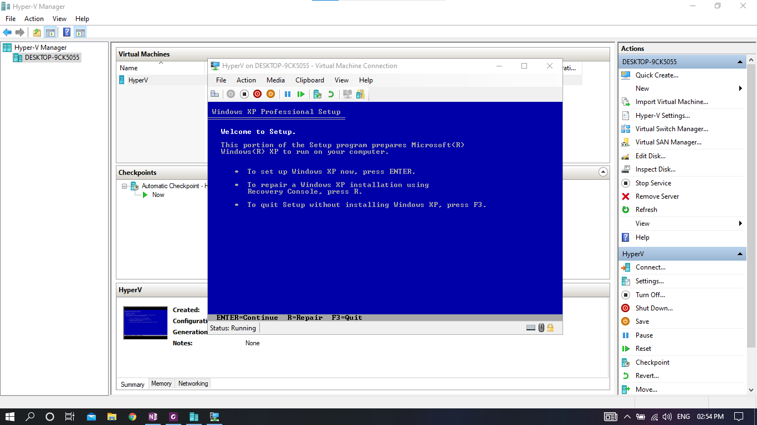

Step 20 – now windows xp is ready for setup and will work in hyper-v

